Chapter 1 Technical Characteristics and

Specifications of the Petrol Engine
Model |  | LJ465Q-1ANE1
Type |  | Four-cylinder, four stroke, water cooling, inline, multiple spherical combustion chamber, overlapping camshaft, electronic fuel injection and electronic control ignition
Cylinder diameter |  | 65.5 mm
Piston stroke |  | 78 mm
Compression ratio |  | 8.8:1
Displacement |  | 1.1 L
Rated power |  | 38.5 kW
Maximum torque |  | 83 N·m/(3000 rpm ~3500 rpm)
Minimum fuel consumption |  | 275g/ kW·h
Rated revolution |  | 5200 rpm
Idle speed |  | (900±30) rpm
Idle discharge |  | GB14761-99 Co≤3.5%
Rotation |  | Clockwise (viewed from the front side of the engine)
Work order |  | 1-3-4-2
Engine oil pressure |  | 0.924Mpa~0.490Mpa (3000rpm)
Overall dimensions |  | (L×W×H) 451×550×647 mm
Net quality |  | 95 kgs excluding the transmission
Fuel grade |  | Over than No. 90 unleaded gasoline (GB17930-1999)
Oil grade |  | SP 15W/40 or API SG SAE15W40 gasoline engine oil is used at above -20℃ of ambient temperature;  SP 15W/30 or API SG SAE15W30 gasoline engine oil is used at above -20℃ of ambient temperature
Engine oil amount |  | 2.7L (newly fitted engine oil filter) |  |  | 2.5 L (old engine oil filter)
Coolant |  | Ethanediol water solution or soft water
Clutch | Type | Single, membrane spring
Clutch | Overall dimensions | (Pressure plate housing): Φ271×33.6 mm
Clutch | Weight | 2.7 kgs
Transmission | Every gear ratio | Four-gear transmission |  |  |  | Five-gear transmission
Transmission | Every gear ratio | 1st gear | 3.818 |  |  | 3.818
Transmission | Every gear ratio | 2nd gear | 2.210 |  |  | 2.210
Transmission | Every gear ratio | 3rd gear | 1.423 |  |  | 1.423
Transmission | Every gear ratio | 4th gear | 0.906 |  |  | 1.033
Transmission | Every gear ratio | 5th gear |  |  |  | 0.844
Transmission  Transmission | Every gear ratio | Reverse gear: 3.583
Transmission  Transmission | Main reduction ration | 4.444
Transmission  Transmission | Type | Gear engagement, synchronizer, four forward gear, one reverse gear |  | Gear engagement, synchronizer, five forward gear, one reverse gear
Transmission  Transmission | Overall dimensions | (L×W×H)  306×394.5×440 mm³ |  | (L×W×H)  342.7×394.5×440 mm³
Transmission  Transmission | Weight | 23 kgs |  | 25 kgs
Transmission  Transmission | Lubrication | 85W/90 GL-4 or GL-5 gear oil GB 13895-92  or fix the brand in special areas according to the application environment and temperature
Transmission  Transmission | Amount of lubrication | 2.1 L

Note: The idle discharge standard of the petrol engine is national mandatory regulations and will be continuously amended. Model LJ465Q-1ANE1 petrol engine will continuously meet the requirements of the latest national standard.

Chapter 2 Application of the Petrol Engine

Section 1 Brief Introduction

Model LJ465Q-1ANE1 petrol engine adopts multi point jet close-loop control petrol engine management system which has characteristics of grouping ignition and grouping jet and functions of advanced discharge control, idle speed control and evaporating pollution control. This system is centered by an electronic controller (ECM) and precisely controls the performer according to the output signal from air intake pressure sensor, thus controlling the oil jet and ignition of the petrol engine under every working condition. In the event of fuel closed-loop control, the electronic controller can modify the oil jet quantity according to oxygen sensor signal to make mixed gas of fuel and air keep theoretical equivalent air & fuel ratio so that three way catalytic converter is purified and discharge with maximum limit to reduce the contents of carbonic oxide (CO), hydrocarbon (HC) and nitrogen oxide (NO_{x}) during air discharge of the petrol engine.

System function

1、Idle speed closed-loop control
The idle speed working condition control of the petrol engine is closed-loop control under the proper working temperature. The electric jet system completely closes the air throttle under the idle speed working condition and controls the air intake quantity during the idle speed running of the petrol engine with the idle speed regulator attached to the air throttle body. Also, ECM of the petrol engine real-time monitors the revolution of the petrol engine and compare it with system preset target idle speed value to timely adjust the idle speed control valve and advance angle of ignition so as to ensure the petrol engine rotates smoothly.

2、 Ignition timing control system
This system is No. 2 generation direct ignition control system of DELPHI company, it has functions of ECM ignition timing automatic control and charging time preset control. This system adopts grouping ignition technology, so ECM ignites the driving circuit each time to ignite the spark plugs of two cylinders at the same time; the ignition of the cylinder which is in compressed stroke to drive the petrol engine is called “Effective Ignition” and the ignition fails to drive the petrol engine in the discharge stroke is called “Ineffective Ignition”.
When running the petrol engine, the electronic controller can determine the preset value of ignition advance angle according to the load information and revolution signal and modify it according to the cooling liquid temperature signal to obtain precision ignition advance angle so as to determine ignition timing.
3．Multiple-point fuel injection system
This system is multiple-point sequential fuel injection system, four oil injectors of four cylinders inject oil in the order of 1-3-4-2. Every injector injects oil once for every two crankshaft revolutions of the petrol engine.
4、Discharge system of waste gas
This system is closed-loop fuel control system with heating oxygen sensor, the oxygen sensor provides the oxygen concentration signal during air discharge for ECM, ECM will adjust oil injecting quantity of the system according to this signal to run the petrol engine with the theoretical air & fuel ratio (14.7:1) so as to ensure optimum the change efficiency of the catalytic converter.
5、 Evaporating discharge pollution control
This system can control the cleaning speed of activated canister according to the running working condition of the petrol engine and cleaning opportunity to control canister cleaning of the vehicle.
6、 Fault diagnosis
Model LJ465Q-1ANE1 petrol engine has fault self-diagnosis function, when system parts have fault, ECM will light fault lamp to remind the driver to repair the vehicle. At that time, the system will ensure the users drive the vehicle to the repairing station to repair in the event of protection of the petrol engine.

System parts

1、 Engine control module (ECU, see Fig)
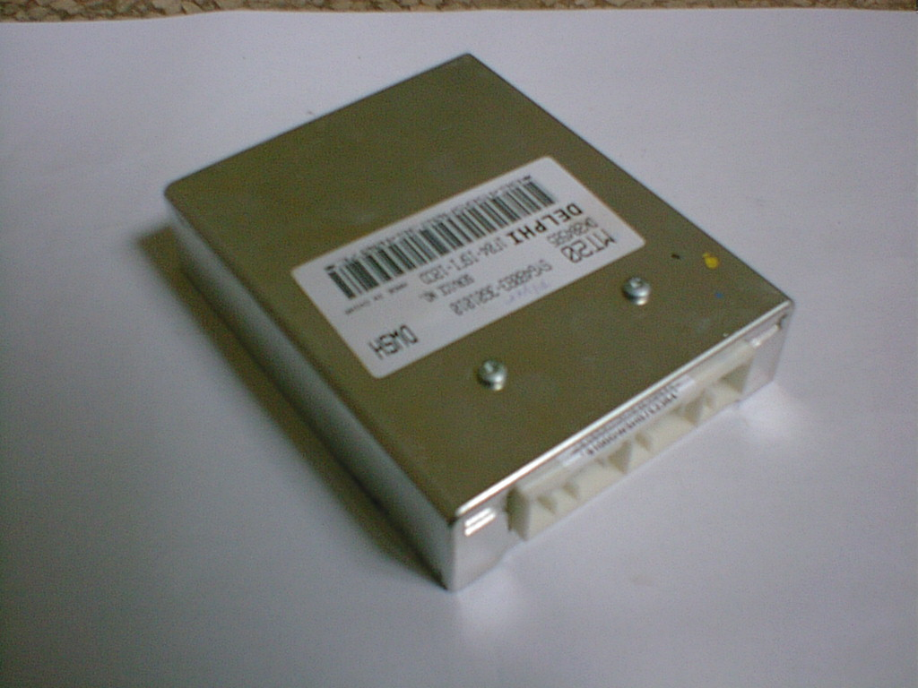
Engine control module (abbreviated to ECU), core part of electric jet system, controls the petrol engine by the sensor and performer. During working, the sensor sends every working condition data of the petrol engine such as air intake pressure, cooling liquid temperature, air intake temperature, oxygen concentration value in waste gas etc. to ECM which sends the command to the performer after treating them accordingly and adjust the petrol engine by the performer.
Operating data
Proper operating voltage: 9.0V~16.0V
NotProper operating voltage: 6.3V~9.0V, 16V~24V
Operating temperature: -40℃~85℃
over load protect：-12V ～24V
2、 Crankshaft position sensor (see Fig):
It is installed on the clutch shell to provide revolution and crankshaft phase signal that provides the reference point for oil infection timing and ignition timing.
When No.1 cylinder and No.4 cylinders of the petrol engine are located at top dead center position, crankshaft position sensor just aligns No. 20 gear of flywheel signal gear (counting from two gear notch clockwise, the observing direction is rear end of the petrol engine).
Operating temperature: -40℃~165℃
Air gap: (refer to the gap between core end of the sensor and signal tooth top). 0.8mm~1.2mm
output：400mV@60rpm
coil resistor：540Ω
coil induction ：240Mh@1kHz

3、 Ignition coil assembly (Fig.)
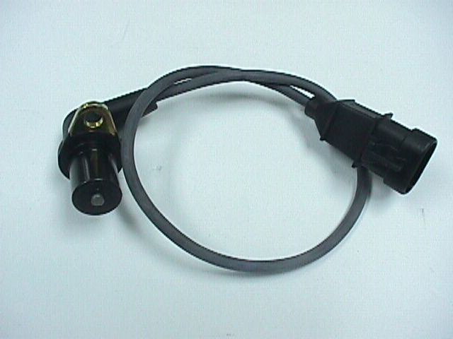
This petrol engine management system adopts advanced distributor direct ignition technology, integral ignition driving circuit fitted in the electronic controller sends out the ignition signal to primary winding of both ignition coils that contain two separate coils to control the spark plugs of No. 1 & No. 4 cylinders and No. 2 & No. 3 cylinders. When two spark plugs of No. 1 & No. 4 cylinders or No. 2 & No. 3 cylinders ignite at the same time which are controlled by the electronic controller, the air pressure inside one cylinder is very low in discharge top dead center, therefore, a little quantities of igniting energy (about 5% of igniting energy) is needed to break down the electrode of the spark plug to be ignited, this ignition is ineffective ignition in fact; mixture gas density inside another cylinder is very high at compressed stroke top dead center, large quantities of igniting energy (about 95% of igniting energy) is needed to ignite the spark plug of this cylinder, the ignition of this cylinder is effective ignition.
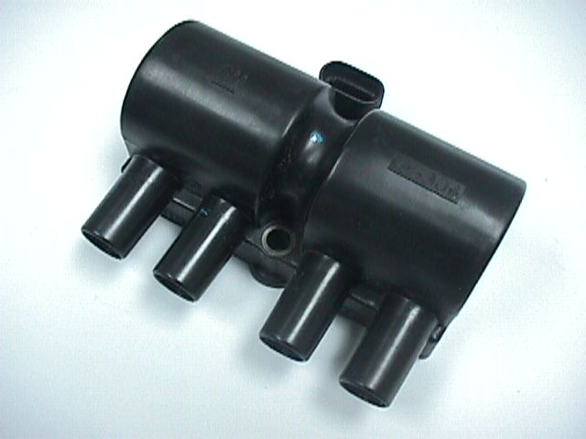
Fitting support of the ignition coil must be grounded safe.
Operating data
Primary coil resistance: 0.5Ω±0.05Ω
Secondary coil resistance: 5200Ω±400Ω
Operating temperature: －40℃~125℃

4、High-tension cord unit
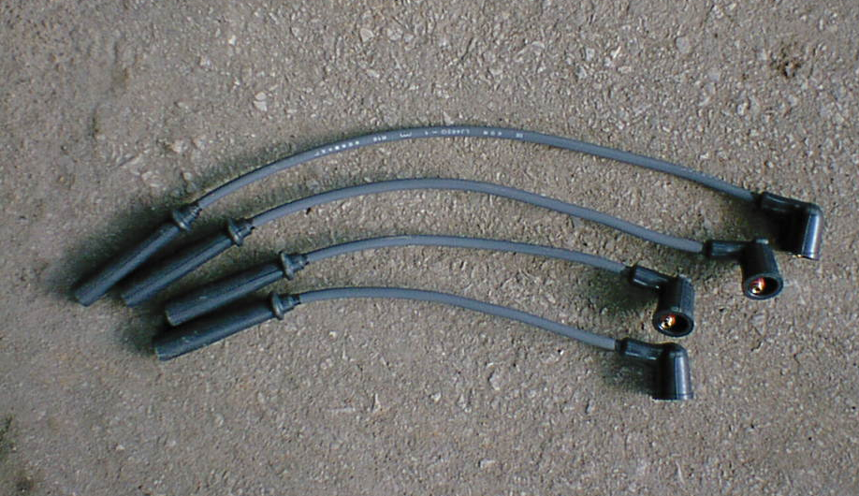
The function of high-tension cord is to transmit the secondary voltage produced by the ignition coil to the spark plug of every cylinder in turn so that the electrode of the spark plug produces the electric spark to light the mixing gas to run the petrol engine.
Note: Hold the protective casing of the high-tension cord by hand when connecting high-tension cord unit, when pulling them out. It is forbidden to hold the cable body by hand and exert your strength to pull out it. Lightly pull them out by holding the protective casing so as to avoid damaging the high-tension cord!
5、 Cooling liquid temperature sensor (Fig.):
it is fitted on circulating water channel on the cylinder head to provide the cooling liquid temperature signal to modify the oil injecting quantity and ignition timing.
If necessary, clean the sensor with isopropanol and air-dry it. Note: Don’t immerse the sensor into isopopanol for over one minute, and avoid the cleaning fluid into the sensor!
Operating data:
Operating voltage: 5V
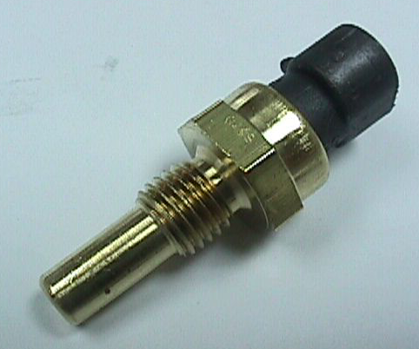
Operating temperature: －40℃~135℃

6、Intake pressure / temperature sensor (MAP/MAT) sensor (Fig):
assembled in the intake manifold chamber , its function is to provide the pressure signal from intake manifold pipe to ECM.
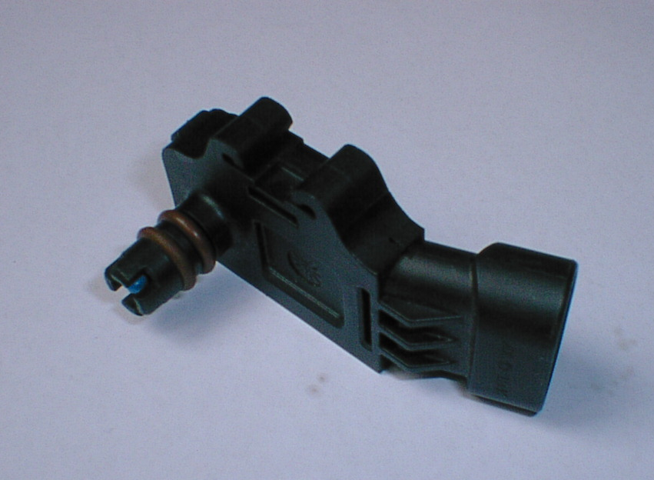
Operating data
Operating voltage: 5V±0.1V
Operating temperature: －40℃~105℃
Pressure scope: 15kPa~102kPa
Operating current: 12mA (maximum)

7、 Fuel track assembly (Fig.)
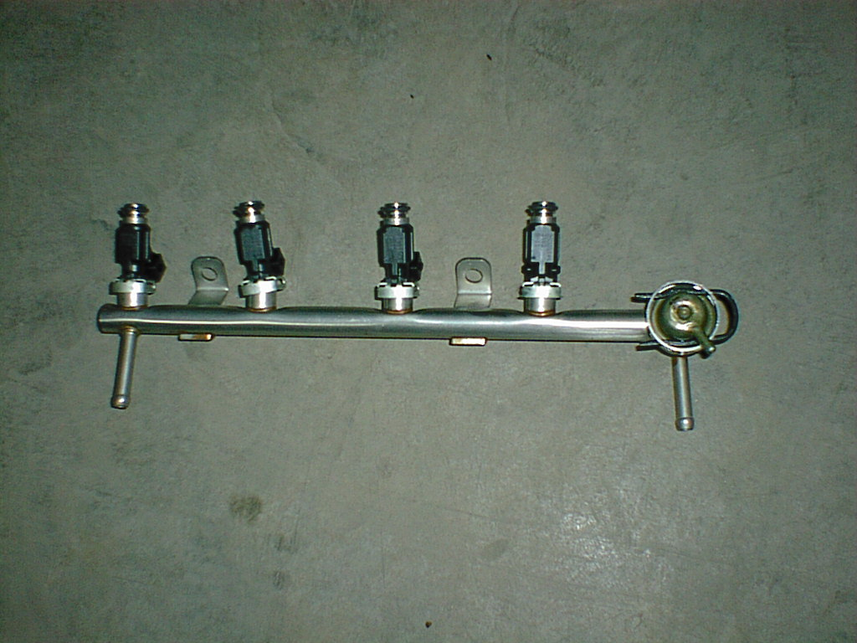
Fuel track assembly consists of fuel track, oil pressure regulator and oil injector that are fitted between the upper body and lower body of the intake manifold pipe. The function of the oil track assembly is to distribute the fuel oil to every cylinder. During the distribution of the fuel oil, ECM can realize the purpose of precision oil supply by controlling open time of the oil injector.
Operating data
Operating temperature: －40℃~115℃
System pressurization: 750kPa
7．1 Fuel injector (Fig)
Fuel injector timely and precisely injects the proper quantity of fuel oil into the air intake manifold pipe according to ECM signal of the petrol engine. ECM controls time of oil injecting quantity according to revolution, cooling liquid temperature, air intake quantity (air throttle opening), revolution sensor signal and residual oxygen content of air discharge of the petrol engine.
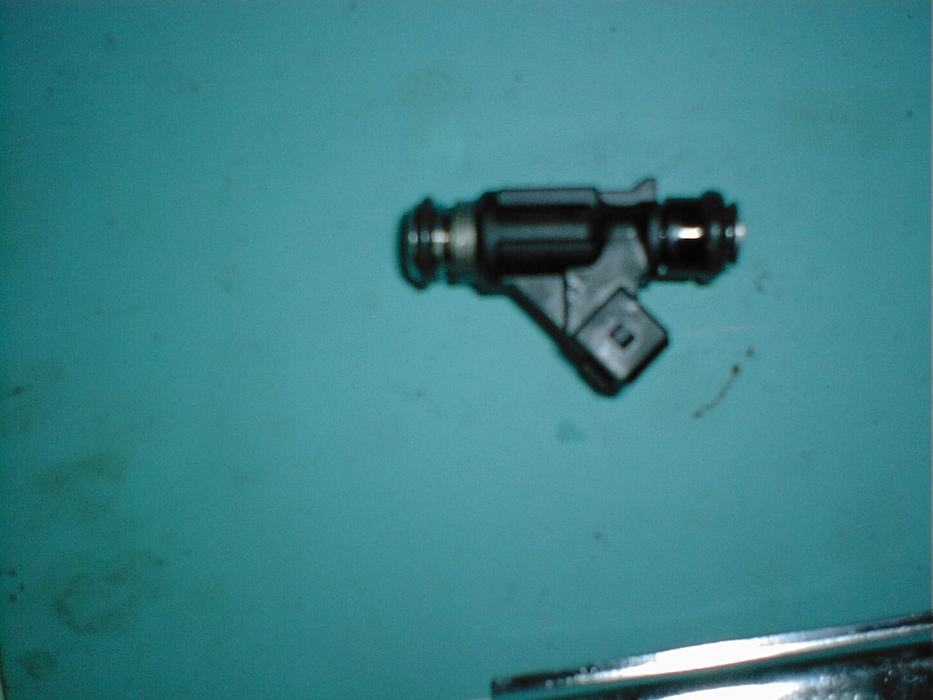
Operating data
Operating voltage: 12V
Operating temperature: －40℃~130℃

Fuel oil pressure: 300kPa
Coil resistance: 12Ω±0.4Ω(maximum)

Precautions for Removing and installing of oil injector
Operation | Causes
Permit: Be careful to remove and install wire. | Avoid damaged ground end.
Permit: Avoid any fluid polluting the oil injector. | Short circuit of coil.
Forbid: Use any voltage except system voltage to test. | Damage may be caused.
Forbid: Move the package to collide between elements. | Minimum penetrating capacity of air is affected or other damage is caused.
Forbid: Seek, raise or move parts to collide elements. | Damage may be caused.
Permit: Install move-restrict clip with a proper installing tool. | Or parts may be damaged or oil-controlling device is disrupted.
Permit: Remove or install one element from package pan each time. | Or key element may be damaged.
Forbid: Use the fallen element | Inner parts may be damaged or oil-controlling device is mixed.
7．2 Oil pressure regulator (Fig)
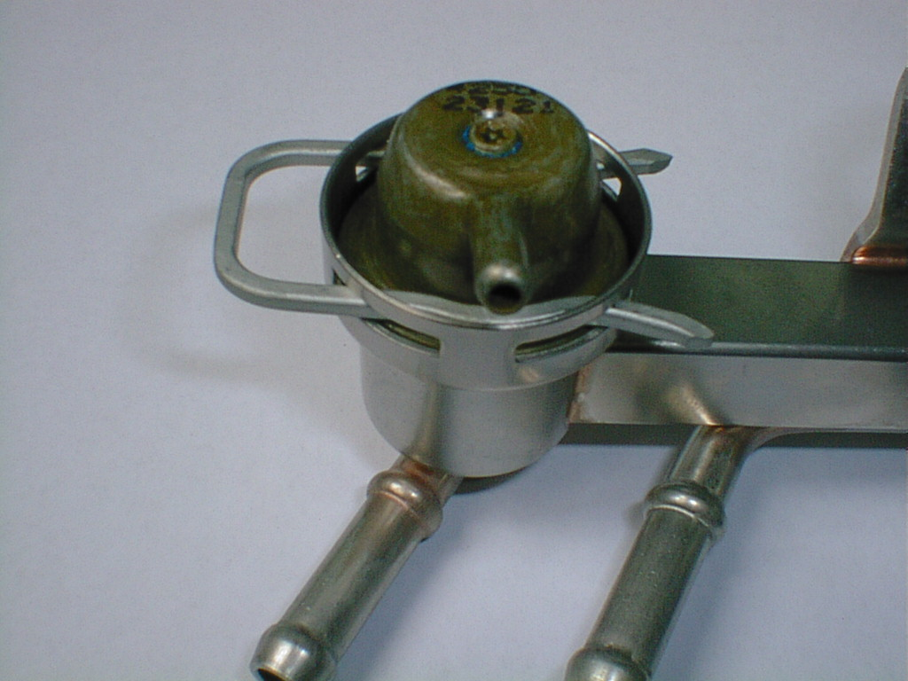
The function of oil pressure regulator is to adjust oil-injecting pressure to keep pressure at the same level in the inlet and outlet injector in the fuel track
Operating data:
Preset pressure: 300kPa
Operating temperature: －40℃~120℃

7．3 Removing and installing of oil track assembly
Precautions for Removing of oil track
Operation | Causes
Permit: Be careful to remove or install | Prevent the oil injector and o-ring from being damaged and socket of oil injector from being damaged.
Permit: Use new O-ring when reinstalling oil injector nozzle. | Avoid fuel oil leaking.
Permit: Install oil supply, return pipe and tighten with a proper torque. | Avoid fuel oil leaking.
Forbid: Insert matters into oil outlet of the regulator. | The valve is pushed up or damaged to malfunction the regulator.
Forbid: Apply excessive side load, especially in nozzle socket. | Needle valve may be bent to damage mechanic and electric performance.
Forbid: Install the oil injector in the intake pipe, apply excessive force on the oil track shell. | Oil injector, oil track and O-ring are damaged.
Forbid: Immerse oil injector into lubricant. | Clogged oil injector hole.
Forbid: Directly connect the oil injector with over 6V current for 10 seconds. | Damaged oil injector.
Forbid: Apply non-fuel soluble lubricant on the O-ring of the oil injector (proper lubricant name marked on the shell). | Clogged regulator or oil injector.
Forbid: Adjust the pressure adjusting screw of oil pressure regulator. | Oil pressure preset value is changed to cause oil injector out of control.

8、 Canister Solenoid Valve (Fig)
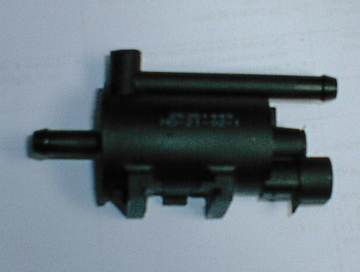
Canister solenoid valve is fitted between the evaporating discharge canister and intake manifold pipe. ECM adjusts the opening of the canister solenoid valve to control the gasoline evaporating in the canister to enter and burn in the intake manifold pipe so as to greatly reduce the discharge of vehicle.
Operating data
Operating voltage:8V～16V
Limited voltage：25V（〈60S’〉
Operating temperature:：-40℃～120℃
Resistor：19Ω～22Ω
Induction：12 mH～15mH

9、 Throttle assembly (Fig)

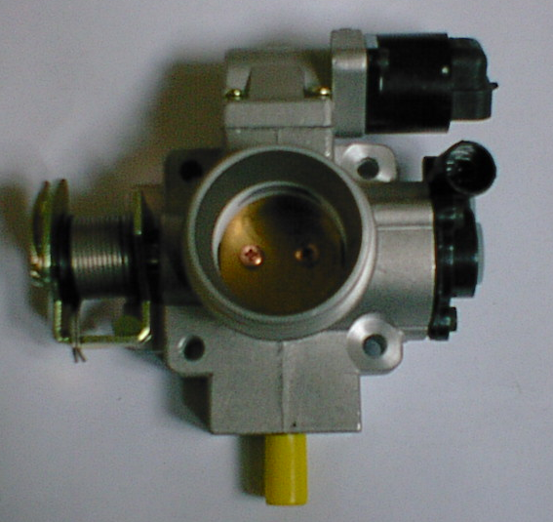
（TPS）
（IACV）
Throttle assembly is an important unit of electric jet system, which comprises throttle body, throttle position sensor (TPS) fitted on the throttle body and idle speed control valve. The function of throttle position sensor (TPS) is to measure the throttle position and feedback to ECM to control fuel supply. Idle speed control valve is used to adjust idle speed bypass air quantities to control the idle speed revolution of the petrol engine.

9．1 Throttle position sensor (TPS)
Measuring scope: 7%~93% of open angle
Operating temperature: －40℃~150℃
Operating voltage：5 V±0.1V
9．2 Idle speed air control valve
It is used to adjust bypass airflow to ensure smooth idle speed running of the petrol engine.
Operating voltage: 7.5V~14.2V
Limited voltage：3.5V～14V
Coil resistor：53Ω±5.3Ω
Coil reduction：33mH±20% mH

9．3 Removing and installing of throttle body assembly

Operation | Causes
Permit: Be careful to remove or install the socket of wiring. | Avoid damaged connecting terminal.
Permit: Avoid throttle body surface contacting fluid pollutant. | Ensure proper function.
Forbid: Keep without the protective cap. | The pollutant may affect proper function.
Forbid: adjust the adjusting screw of throttle pull wire support. | Preset before ex-factory is affected to cause system malfunction.
Forbid: Apply voltage specified not by system when testing. | Damage is caused.
Permit: Install the move-restrict clip with a proper installing tool. | Or parts may be damaged or oil control device is disrupted.

10、 Oxygen sensor (Fig)
Oxygen sensor is an important element of closed-loop control system, which is fitted on the exhaust of air discharge pipe to provide ECM with oxygen concentration signal of mixture air to modify the oil injecting quantities to carry out closed-loop control for air & fuel ratio.
Work process of oxygen sensor: zirconium oxide element is heated by air discharge to activate and make air enter the central parts (electrode) of zirconium oxide, and air is discharged to pass the outer electrode of zirconium oxide. Oxygen ion moves toward outer electrode from center of zirconium oxide, so a simple primary cell is formed, which is produced voltage between two electrodes. Also, the oxygen sensor can change the output voltage according to oxygen content of air discharge.
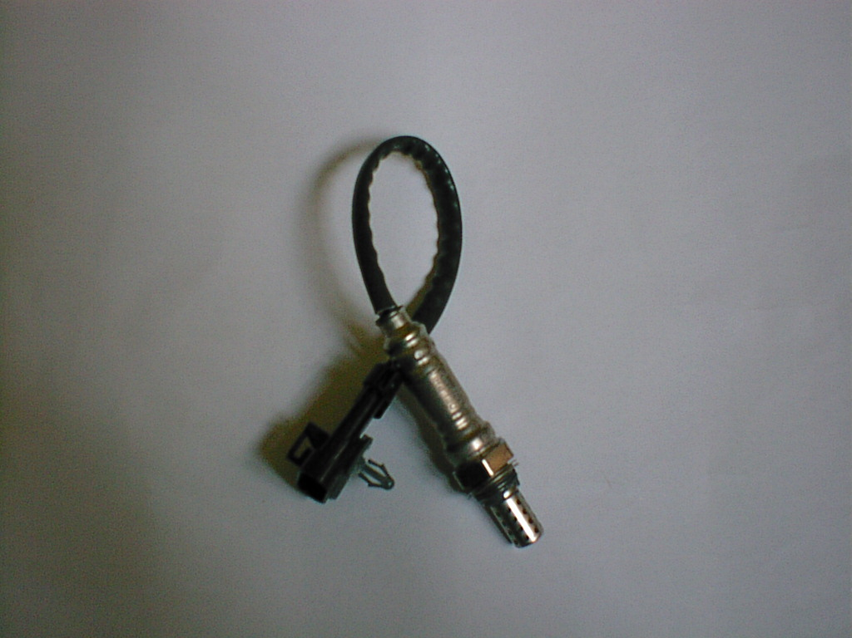

Operating temperature:
Discharge temperature: 260℃~850℃
max temperature：125℃

Precautions for installation and service of oxygen sensor
Operation | Causes
Forbid: Fall the oxygen sensor or collide with hard surface. | Violent vibration may damage ceramic elements or heating elements.
Forbid: The sensor is polluted by carbon deposit, silicone oil, engine oil lead, paint or other organic matters which is discharged by the petrol engine. | The pollutant may affect the sensor output signal and cause permanent damage.
Forbid: Draw out the sensor wire. | Excessive drawing may damage the reliable connection of wire to affect proper service of the sensor.
Forbid: Tie, press or damage the wiring of the sensor. | Wiring damage may cause some problems of reference air or voltage.
Forbid: Use grease, cleanser or other foreign matters on the socket. | These matters may cause sensor trouble.
Forbid: Use solder on the sensor wiring or wire of wiring | Please use special thermal shrinkage pope packed by Delphi company. Don’t try to repair the sensor wire.
Installation for fitting
Permit: Tighten the oxygen sensor till the specified torque. | Tightening the sensor till the specified torque may avoid some problems such as durability, discharge leakage and difficult removal etc.
Forbid: Use fluid when installing the socket. | This may pollute the reference air.
If removing is needed
Permit: Slightly heat the discharge system. | The sensor is easy to be removed. Note: the heating temperature is not too high so as not to affect operation safety.
Permit: Use thread loose agent (proper), only use in thread area. | Loose thread agent may reduce damage for thread during removing.
Permit: Clean foreign matters on the installing hole of the sensor. | Avoid burning after new sensor is installed.
Permit: If removing the sensor to reinstall it on the petrol engine, replace the gasket, apply burning prevention compound on the thread again. | Note: only apply to thread.

Section 2 Notices to Application of the Petrol Engine

1、 Manual
Because the petrol engine adopts advanced petrol engine management system, it has specific characteristics in many aspects compared with carburetor petrol engine, which makes the driver comfortable and maintenance more convenient and simpler.
Please read this manual carefully, and serve and maintain the petrol engine according to the various regulation recommended by this manual.
2、Cooling liquid
Check for the cooling liquid of the petrol engine, if insufficient, replenish the cooling liquid.
Note: When running the petrol engine, the cooling system must have sufficient cooling liquid to ensure the petrol engine works properly, otherwise, the vehicle will be boiled.
The petrol engine works under excessive heat, it will affect the service life of the petrol engine, even result in severe trouble such as scuffing of cylinder bore.
3、 Engine oil
Check the oil level of the engine oil of the petrol engine, if insufficient oil is found, replenish in time. Refer to Section 1,Chapter 3 for the method of checkup and filling of the engine oil, use the engine oil conforming to standard, if nonstandard engine oil is used, it will damage three way catalytic converter.
Note: Insufficient oil will result in too low pressure of the engine oil of the petrol engine and poor lubrication, severe worn petrol engine and poor cooling, thus cause the trouble of the petrol engine to affect life of the petrol engine.
4 Fuel oil
Vehicle unleaded gasoline (GB17930-1999) No.90 or above must be used.
Note: Unleaded gasoline conforming to standard must be used for vehicle, otherwise, management system of the petrol engine and three way catalytic converter will damaged fatally to reduce the environmental protection performance of vehicle.
5 Starting the petrol engine
When starting the petrol engine, set the key of the ignition switch to “Starting” position, the petrol engine is started by the engine. Once the petrol engine is ignited, release the key to turn off the engine power.
5.1 The petrol engine provides proper air & fuel ratio of oil and air mixture and ignition advance angle under any working condition. Therefore, in any weather, it is not necessary to step on the accelerator.
5.2 If you try many times to start the petrol engine and fail, the petrol engine may result in short circuit of the spark plug owing to overflow, so floor the acceleration pedal and start the petrol engine again (at that time the electronic controller will control the nozzle to cut off oil supply), high speed flow will blow out the overflow within 5 or 6 seconds. Release the accelerator pedal and start the petrol engine again.
Note: Don’t make the starter motor work each time for over 5 seconds. If you can’t start the petrol engine, start it again for the second time at 10-second interval, otherwise, the starter motor will be damaged. If you can’t start it for several times, please check fuel system and electric system or repair in the petrol engine factory and repairing station of our factory.
6 Idle speed
Normal idle speed is 750±50 r/min.
The petrol engine is heated at about 1000r/min of revolution under the control of the electronic controller when it is cooled. The revolution of the petrol engine will resume with rise of water temperature of the petrol engine.
7 Running
During running of the petrol engine, the temperature of the cool fluid is kept at 80~90℃. Oil pressure is no less than 245kPa with middle vehicle speed.
Never run with neutral when running, because vehicle with electric jet system has function of decelerating and oil cut-off, which has good economic efficiency. The petrol engine can work with idle speed when running at neutral position, it still consume fuel. So running at neutral position is not beneficial to save oil.
8 Stop
When the petrol engine works, especially run with high speed and high load don’t stop it at once, stop it when it runs with low speed for 3~5 minutes. When stopping, never stop on the inflammable materials such as hay etc. so as to avoid three way catalytic converter with high temperature resulting in fire.
9 Rainy day or wading
When passing on the ponding road in rainy day or running with water ordinarily, ensure sealing of air filter is good, otherwise resulting in water into the petrol engine and damaging parts such as connecting rod etc.
Note: Water is non-compressible fluid, after water enters the cylinder, under vehicle inertia, the connecting rod will bear pressure corresponding to tens of times under normal condition that results in bending or breaking the connecting rod.
10 Warm-up in winter
The air temperature is too low in winder, the viscosity of engine oil is increased, the lubrication efficiency of the petrol engine is worse than in summer, therefore, don’t run the petrol engine at once after starting it, don’t run it under high speed and heavy load, warm it up with idle speed for 10 minutes so as to make the oil temperature and cooling liquid temperature rise to fully lubricate the petrol engine, then run the petrol engine.
Notes: run the petrol engine without fully lubrication in winter, this will result in excessive wear even anti-locking of distributor mechanism parts such as camshaft etc.
11 Gasoline piping
Notes: Because oil supply pressure is up to 0.3Mpa, e.g. 3 atmosphere, explosion-proof rubber pipe should be used for oil intake and return pipe, oil pipe must be tightened with the clamp, often check if the pipe joint is leaked. When checking the oil piping, it is forbidden to remove the oil intake and return pipe of the oil track, and start the petrol engine to check electric fuel pump, otherwise, gasoline drain may cause fire.
12 Injector
According to actual use condition of gasoline in China, when the vehicle is placed for a long period, the petrol engine should be started for 2 or 3 minutes once every 2 or 3 months, so as to avoid clogged injector owing to gasoline gum.
13 Throttle body
Throttle body is the meter for the air intake quantity of the petrol engine, every performance index is set to be qualified before ex-factory. Users can adjust the throttle adjusting screw by themselves to reach the purpose of revolution and discharge adjustment when using the throttle body, otherwise, this will damage correct data of the throttle position sensor, thus affecting the performance and discharge of the vehicle. If fault is found, ask the specialized person to repair.
14 Electric fuel pump
If oil quantity is insufficient, don’t run the petrol engine, otherwise, the electric fuel pump will not work properly.
15 Fault indication
If fault is found when the petrol engine runs, the fault lamp on the meter will be on, at that time, please send the vehicle to repair in the repairing station as soon as possible, the repairing person read the fault code from fault diagnosis instrument, repair the petrol engine according to the cue from fault diagnosis instrument.
Notes: When some electric jet parts are found fault, the vehicle still can keep running, the driving performance is getting worse, which reminds the driver should send the vehicle to repair.

Trouble Code List
Trouble Code | Trouble Descriptions
P0105 | Too high intake manifold pressure
P0105 | Tow low intake manifold pressure
P0110 | Too low intake manifold temperature
P0110 | Too high intake manifold temperature
P0115 | Too low coolant temperature (circuit open or shorted to battery)
P0115 | Too low coolant temperature (circuit shorted to earth)
P0120 | Too high throttle-valve position (circuit open or shorted to battery)
P0120 | Too low throttle-valve position (circuit shorted to earth)
Trouble Code | Descriptions
P0130 | No signal from the oxygen sensor
P0170 | Excessive rich period of the oxygen sensor
P0170 | Excessive thin period of the oxygen sensor
P0201 | Circuit malfunction of injector A（cylinder 1）
P0202 | Circuit malfunction of injector B (cylinder 3)
P0203 | Circuit malfunction of injector C (cylinder 4)
P0204 | Circuit malfunction of injector D (cylinder 2)
P0230 | Fuel pump relay circuit shorted to battery
P0230 | Fuel pump relay circuit open or shorted to earth
P0335 | No signal from 58X crankshaft sensor
P0335 | Signal malfunction of 58X crankshaft sensor
P0351 | Coil 1-4 circuit shorted to battery
P0351 | Coil 1-4 circuit open or shorted to earth
P0352 | Coil 2-3 circuit shorted to battery
P0352 | Coil 2-3 circuit open or shorted to earth
P0443 | Carbon canister solenoid valve circuit shorted to battery
P0443 | Carbon canister solenoid valve circuit open or shorted to earth
P0480 | Fan 1 circuit shorted to battery
P0480 | Fan 1 circuit open or shorted to earth
P0481 | Fan 2 circuit open or shorted to battery
P0481 | Fan 2 circuit open or shorted to earth
Trouble Code | Trouble Descriptions
P0500 | No signal from the speed sensor
P0505 | Idle control malfunction
P0560 | Excessive battery voltage
P0650 | Failure indicator circuit shorted to battery
P0650 | Failure indicator circuit open or shorted to earth
P1530 | Air conditioner relay circuit shorted to battery
P1530 | Air conditioner relay circuit open or shorted to earth
P1604 | EEPROM memory malfunction
P1605 | FLASH memory malfunction
P1610 | Burglar-proof controller malfunction
P1610 | Communication error between ECU and burglar alarm
P2000 | Too high temperature of the front evaporimeter
P2000 | Too low temperature of the front evaporimeter
P2001 | Too high temperature of the rear evaporimeter
P2001 | Too low temperature of the rear evaporimeter
P2100 | Rear circulation cut-off valve of air conditioner circuit shorted to battery
P2100 | Rear circulation cut-off valve of air conditioner circuit open or shorted to earth

Section 3 Running-in of the Petrol Engine
The service life of the petrol engine is mainly dependent on the earlier use. New petrol engine should be run-in in the vehicle for 2500 kilometers according to the running-in standard or for 30 hours according to the running-in standard on the test-bed.
The following should be done to run-in the petrol engine in the vehicle:
1. Check
Check engine oil, coolant, gasoline, battery electrolyte for sufficiency, replenish and repair if insufficient amount and leakage.
2. Road surface
Vehicles should run on the cement or asphalt road surface, do not attempt to run on other road surfaces, especially on sand & mud roads.
3. Running-in standard
The petrol engine should be run-in on the vehicle, follow the running-in standard of the petrol engine shown the following table, it is not allowed to be higher than every gear speed shown in the following table. If there exists between the vehicle running-in standard and this standard, this standard should be followed.
Running-in Standard of New Petrol Engine Fitted in the Vehicle
Transmission gear | Vehicle Speed
1st gear | 10 km/h
2nd gear | 20 km/h
3rd gear | 35 km/h
4th gear | 55 km/h
5th gear | 65 km/h
4. Load
During running-in, the vehicle load is not allowed to exceed 50 % of rated load in the first 1000 kilometers and 75 % of rated load in the next 1500 kilometers.
5. Maintenance
The petrol engine should be maintained according to the specified items shown in the following table after running-in new vehicle for 2500 kilometers.
Maintenance Items after Running-in New Petrol Engine
No. | Items | Maintenance contents
1 | Generator belt | Check wear and adjust tension
2 | Synchronous chain tensioner | Check flexibility and adjust tension
3 | Throttle valve clearance | Check, adjusting if necessary | Cold | 0.13mm～0.18mm
3 | Throttle valve clearance | Check, adjusting if necessary | Warm | 0.23mm～0.28mm
4 | Cylinder head bolt and fixed nuts of intake & exhaust manifold | Tighten according to the specified torque
5 | Engine oil filter | Replace
6 | Engine oil of the petrol engine | Replace
7 | Transmission gear oil | Replace
8 | Spark plug clearance | Check and adjust to the specified value
9 | Idle speed and discharge | Check idle and discharge value and adjust according to regulations

Chapter 3 Maintenance of the Petrol Engine

Section 1 Maintenance of the Lubrication System
1. Oil used for the petrol engine
When ambient temperature is over than -20℃, SF15W/40 gasoline engine oil（or API SG SAE15W40 gasoline engine oil）is used;
When ambient temperature is lower than-20℃, SF5W/30 gasoline engine oil（GB11121-1995）or API SG SAE5W30 gasoline engine oil is used.

★★
Replace engine oil after running-in new petrol engine for 2500 kilometers and run smoothly every 5000 kilometers.

2. Engine oil level of the petrol engine
Engine oil amount inside the engine oil tray is measured with a dipstick on the right side of the petrol engine. Perform measurement after the petrol engine stops running for about 5 minutes, draw out the dipstick, wipe out engine oil with a piece of clean cloth, then insert engine oil tray again and measure engine oil level.
Check engine oil level before running, engine oil level should be kept between the upper limit and lower limit of the engine oil dipstick, if oil level is near or lower than the lower limit, replenish engine oil to the upper limit.

3. Replace engine oil of the petrol engine
Change engine oil of the petrol engine on the asphalt road surface once every 5000 kilometers, often check it on the severe sand and mud, change in time according to the oil quality, but it’s not allowed to exceed once every 5000 kilometer.
When changing engine oil of the petrol engine, warm up the petrol engine for 10 minutes, open the oil cap after stopping the vehicle, and tighten the discharge plug of the engine oil tray of the petrol engine, drain out engine oil and tighten the oil plug. Replenish about 3 liters of new engine oil from oil cap, and close the oil cap.
Start the petrol engine and run for 5 minutes, check for oil leakage, then stop the vehicle, check oil level after stopping the vehicle and wait for 5 minutes, replenish engine oil to upper limit of the engine oil dipstick if insufficient.
★★
When tightening the oil discharge plug, please make sure not to be burnt by engine oil.
4. Engine oil used for the transmission
85W/90 GL-4 or GL-5 grade gear oil，GB13895-92 or No. 18 dual-curve gear oil.
★★
Proper lubrication oil of the petrol engine and the transmission is an important factor to ensure good work and service life, customers should pay special attention to the oil choice, do not mix engine oil with the different production areas, brand and standard so as to prevent the different oil variety to cause chemical change and affect proper work of the petrol engine.
It’s not allowed to use engine oil brand which is not specified, in particular never use imported engine oil.

5. Replacement of engine oil of the transmission
Change gear oil of the transmission once every 40000 kilometers (excluding running-in period).
When changing gear oil of the transmission, warm up the petrol engine for about 10 minutes, screw out the oil plug and oil discharge plug on the extension power-brake behind the transmission after stopping the vehicle, empty out engine oil inside the transmission, screw in the oil discharge plug, replenish gear oil from the oil plug hole till the oil is overflowed.

★★
Never replenish gear oil from the mounting hole of the back-up light switch.

6. Cleaning of lubrication system
If there are excessive foreign matters deposited in the engine oil tray, clean the lubrication system of the petrol engine with light spindle oil.
★★★
Never clean with gasoline or gas oil.
When cleaning exterior parts of the petrol engine, replenish 3 liters of light spindle oil inside the petrol engine from the oil hole, start the petrol engine with the engine and race for 2~3 times once every 1 minute, then quickly drain out the spindle oil used for cleaning, and replenish the petrol engine with engine oil as required again.
After changing new engine oil every time, run the petrol engine at the no load condition for 3~5 minutes so as to ensure sufficient engine oil is available in the lubrication system and its oil supply parts.

7. Replacement of engine oil filter
Replace one engine oil filter once every 10000 kilometers. The fixed torque is 12~16 N·m（1.2~1.6kgf·m）.

8. Check engine oil pressure indication system
Under normal case, when turning the power switch (key) to “ON”, the engine oil pressure indicator comes on, showing no engine oil pressure；turn the switch to “START”, the petrol engine is started at idle speed, at that time, the engine oil pressure indicator automatically goes off, showing normal engine oil pressure. If the engine oil pressure indicator doesn’t go off, showing the engine oil pressure in the petrol engine lubrication system is abnormal, first check engine oil amount of the petrol engine is sufficient.
Turning the switch to “ON”, the engine oil pressure indicator goes off, but the engine oil pressure switch is connected to the bonding iron of the body at idle, the engine oil pressure switch cuts off the bonding iron of the body, showing the engine oil pressure switch works normally. At that time, check the indicator and related circuit have malfunction.

Section 2 Maintenance of the Cooling System
The cooling system is one of essential conditions to guarantee normal work of the petrol engine, therefore, it’ s necessary to guarantee sufficient coolant inside the petrol engine, perform inspection before running the vehicle every time, replenish in time if insufficient.

1. Coolant
Model LJ465Q-1ANE1 petrol engine is allowed to use distilled water or properly treated soft water and antifreeze as coolant，the freezing point of antifreeze is 5℃ lower than the lowest temperature of used areas.
During the winter seasons, when using water as coolant, a warm warehouse must be provided to keep warm so as to avoid frozen coolant, or drain out the cooling water of the radiator and the petrol engine in time after stopping the vehicle to avoid frost crack of the radiator and the petrol engine. For the petrol engine without a discharge plug in the cylinder, do not use water as coolant in winter.
★
 Water volume can be expanded after frozen, which seals the radiator, water pump, cylinder head, the cylinder body will be burst open.

2. Replenishing coolant
Replenish the coolant according to the following steps:：
(1) Screw out the radiator cap and replenish coolant，fill the radiator with coolant till the storage water barrel level reaches “FULL” graduation. Note: do not allow to exceed “FULL” graduation.
(2) Close and tighten the radiator cap.
(3) Start the petrol engine, run it at idle speed for 2～3 minutes, screw out the radiator cap, as there are some air in the discharge waterway, the coolant level is reduced, at that time, replenish the coolant till “FULL” graduation.
3. Replenish coolant
After long time use, when coolant level in the storage water barrel is lower than “LOW” graduation, replenish the coolant according to the following steps:
If the coolant is reduced greatly in a short time, the cooling system could be leaked, it should be checked carefully.
4. Replace coolant
After long time use, when replacement of the coolant is needed because the coolant is deteriorated or do some repair, the following steps should be followed:
(1) Screw out the radiator cap, open the water discharge valve at the bottom of the radiator and drain out coolant.
(2) Remove the storage water barrel and drain out coolant.
(3) Screw out the water discharge plug on the crankcase and drain out coolant.
(4) Fix the discharge plug of the storage water barrel, radiator, and discharge valve and crankcase as usual, fill the coolant according to the filling steps.

★
When replace coolant, the vehicle should be kept on a level place.

5. Never remove and not fit the thermostat assembly

★★
Not fitting the thermostat assembly will prolong the warm-up time after starting the petrol engine, the petrol engine working at low temperature for a long time will result in rapid wear of the machine parts and affect the service life.

Section 3 Maintenance of the Generator Belt
The generator belt is used to drive the generator, water pump and the pulley of crankshaft, often check and maintain the generator belt.

★★
Sufficient tension or damaged generator belt could result in excessive heat of the petrol engine and reducing generated energy.
1. Adjustment
When the petrol engine is stopped, release two fixed screws in the lower part of the generator and adjusting screws in the upper part of the generator, push the generator outwards till the generator belt reaches the required tension shown in Section 2 of this chapter.

2. Tension measurement
As shown in the left drawing, 98 N·m (10 kgs) is applied to the generator belt between the water pump and crankshaft pulley, drafts of new generator belt is about 7～10 mm, and that of old one is 10～15 mm.
3. Appearance
Appearance of the generator should be in good order, replace in time if it’s poor to affect service.

Section 4 Maintenance of the Petrol Filter
Replace gasoline filter in time so as not to affect oil supply or result in injector clogging.
★★
For the petrol engine with the electric injection system, do not use gasoline filter of the petrol engine with a common carburetor.

Section 5 Maintenance of the Distribution Mechanism and Synchronous Chain

The distribution mechanism and synchronous chain should be often checked and maintained, once the broken synchronous chain will result in collision between the throttle valve and the piston so as to result in damage of the throttle valve, piston, rocker and camshaft. Therefore, besides running-in period of the vehicle, check once every 20000 kilometers and adjust or replace properly if necessary.

★★★
Even if you are expert, we recommend that you should send the maintenance items marked with “*” to the auto plant or technical service station and special repair center of our plant.

1. Check and Adjustment of Timing Sprocket
Open the sprocket chamber cover, check the mounting mark position of driving and driven sprockets is correct, if it’s not correct or timing is not doubted correct, perform inspection according to the following regulations:
Fix the woodruff into the crankshaft keyslot and the locating pin of the sprocket into that of the camshaft. Install inner ring clamped to two connecting bright rings on the timing chain on the opposite teeth of “。”(shown in symbol 2 of the drawing) of the timing sprocket of the camshaft, and the third bright ring (shown in symbol 7 of the drawing) into the gear opposite the lower part of the timing sprocket keyslot of the crankshaft. Install the hung timing sprocket of the timing chain camshaft and that of the crankshaft on the camshaft and crankshaft at the same time, when installing, rotate the timing sprocket of the camshaft to make “。”(shown in symbol 2 of the drawing) at the most upper part, and adjust it to align the “I” (shown in symbol 4 of the drawing) of the cylinder head assembly into a straight line. When rotating the timing sprocket of the camshaft, first confirm the crankshaft keyslot is located inside the drawing mark angle to avoid that the throttle valve is collided with the piston. When mounting the timing sprocket of the crankshaft, make sure the woodruff center is upward, and rotate it clockwise to align the “I” (shown in symbol 4 of the drawing) of the cylinder head assembly into a straight line. When installing the tensioner (shown in symbol 9 of the drawing), make sure the tensioner is flexible to adjust the tension of the timing chain. After tensioning the timing chain, tighten two bolts according to the required torque, install the O ring of the tensioner. When completing installation, the center of two bright rings of the camshaft, symbol 1, 4 & 7 and the third bright ring should be on the same straight line shown in Fig. 5, otherwise adjust it again according to the above-mentioned steps. Mount the limit plate (shown in symbol 5 of the drawing below), the long hole is installed on the upper part, tighten two bolts according to the required torque.

1
3
2
4
5
6
7
8
9
1 Chain bright rings（two pieces）
2 Location mark on the sprocket
3 Camshaft timing sprocket
4 Location mark on the cylinder head assembly
5 Limit plate
6 Crankshaft timing sprocket
7 Chain bright ring（1 piece）
8 Chain
9 Tensioner

Section 6 Maintenance of the Spark Plug
Replace the spark plug after the vehicle runs every 10000 kilometers, always check and replace if damaged, when replacing, pay attention to model F6RTC and screw M14×1.25.
The insulator surface of the center electrode of the spark plug and exterior electrode should be kept clean, carbon deposit is not allowed, remove with fine sand paper if carbon deposit existed.
Clearance of the spark plug is 1～1.2 mm, which is even and same on the overall center electrode.

Section 7 Assembly of Dual-coil Ignition System
The electronic ignition system of model LJ465Q-1ANE1 petrol engine is “dual-coil” ignition system. The electronic ignition system can greatly improve control accuracy of ignition time, work reliability, ignition energy and ignition voltage.
1. Composition
The system is composed of power source, ignition, electronic controller, ignition coil, high pressure damping coil and spark plug etc.
2. Wiring
Ignition coil Ignition fuse 3
Spark plug
Dual-coil ignition system

Section 8 Maintenance of Forced Ventilation Valve (PCV Valve) of the Crankcase
PCV valve is composed of valve body, valve, valve cap and spring, which is decomposable. Its main function is to guide the waste gas in the crankcase into intake manifold through PCV valve and be burnt finally so as to avoid environmental pollution of waste gas in the crankcase, remove it once every 10000 kilometers, wash and clean oil as well as dry it, then push its valve with steel wire and to see if it is flexible. Replace with new valve if the valve is seized up or not ventilated.

Chapter 4 Periodic Inspection the Petrol Engine
Section 1 Service Intervals and Maintenance Content of the Petrol Engine

The service period should be judged according to the odometer or month, subject to the earlier one. |  | kilometers×1000 |  | 2.5 | 10 |  | 20 |  | 30 |  | 40 |  | 50 |  | 60 |  | 70 |  | 80
 |  | Months |  | 2 | 6 |  | 12 |  | 18 |  | 24 |  | 30 |  | 36 |  | 42 |  | 48
1* | Generator belt (check for elasticity and wear) |  |  | A | - |  | I |  | - |  | R |  | - |  | I |  | - |  | R
2* | Synchronous chain (check for damage and wear) |  |  | - | - |  | I |  | - |  | I |  | - |  | I |  | - |  | I
3* | Intake & exhaust throttle valve clearance |  |  | A | - |  | A |  | - |  | A |  | - |  | A |  | - |  | A
4* | Torque of cylinder head bolt and nuts and screws of fixed intake & exhaust manifold |  |  | T | - |  | T |  | - |  | T |  | - |  | T |  | - |  | T
5 | Engine oil filter |  |  | R | R |  | R |  | R |  | R |  | R |  | R |  | R |  | R
The service period should be judged according to the odometer or month, subject to the earlier one. |  |  | kilometers×1000 | 2.5 | 10 |  | 20 |  | 30 |  | 40 |  | 50 |  | 60 |  | 70 |  | 80
 |  |  | Months | 2 | 6 |  | 12 |  | 18 |  | 24 |  | 30 |  | 36 |  | 42 |  | 48
6 | Gasoline engine oil |  |  | Change once every 5000 kilometers
7 | Fuel rubber pipe and connector（aging pipe, cracked or damaged connector） |  |  | I |  | I |  | I |  | I |  | I |  | I |  | I |  | I |  | I
8 | Rubber pipe and connector of cooling system of the petrol engine（water leakage and damage etc） |  |  | - |  | - |  | I |  | - |  | - |  | I |  | - |  | - |  | I
9* | High pressure damping coil（deteriorated and damaged） |  |  | - |  | - |  | I |  | - |  | - |  | I |  | - |  | - |  | I
10* | Spark plug |  |  | - |  | R |  | R |  | R |  | R |  | R |  | R |  | R |  | R
11 | Gasoline pump（check for oil leakage） |  |  | - |  | - |  | I |  | - |  | I |  | - |  | I |  | - |  | I
12 | Air filter |  |  | Clean once every 10000 kilometers for asphalt road.  Clean once every 2500 kilometers for dust road.
13 | Accelerator control pull wire and throttle valve shaft |  |  | - |  | I  L |  | I  L |  | I  L |  | I  L |  | I  L |  | I  L |  | I  L |  | I  L
The service period should be judged according to the odometer or month, subject to the earlier one. |  |  | kilometers×1000 | 2.5 |  | 10 |  | 20 |  | 30 |  | 40 |  | 50 |  | 60 |  | 70 |  | 80
 |  |  | Months | 2 |  | 6 |  | 12 |  | 18 |  | 24 |  | 30 |  | 36 |  | 42 |  | 48
14* | Idle and idle discharge |  |  | A |  | A |  | A |  | A |  | A |  | A |  | A |  | A |  | A
15 | PCV valve |  |  | - |  | I |  | I |  | I |  | I |  | I |  | I |  | I |  | I
17* | Clutch clearance |  |  | - |  | I |  | I |  | I |  | I |  | I |  | I |  | I |  | I
18 | Transmission gear oil（check for oil leakage under a level condition） |  |  | R |  | I |  | I |  | I |  | R |  | I |  | I |  | I |  | R
Notes: the meaning of the symbols in the table:
“A”——Check or adjust “L”——Lubricate “R”——Replace
“I”——Make visual check and adjust or replace if necessary
“T”——Check with special torque spanner

★★
Even if you are expert, we recommend that you should send the maintenance items marked with “*” to the auto plant or technical service station and special repair center of our plant.
Section 2 Torque of Main Bolts of the Petrol Engine

No. | Name | Torque (N·m)
1 | Cylinder head connecting bolt | 55~60
2 | Intake & outlet manifold nutS | 18~23
3 | Spark plug | 20~28
4 | Mounting bolt of camshaft timing sprocket | 55~60
5 | Adjusting nut of throttle valve | 18~20
6 | Mounting bolt of crankshaft timing sprocket | 55~60
7 | Connecting rod bearing cap nut | 28~32
8 | Crankshaft head bolt | 43~48
9 | Flywheel bolt | 40~45
10 | Engine oil tray bolt | 4~5
11 | Oil discharge plug | 30~35
No. | Name | Torque (N·m)
12 | Cylinder head bolt | 4~5
13 | Sprocket chamber cap bolt | 9~12
14 | Oil pressure sensor | 12~15
15 | Engine oil filter pipe nipple | 20~25
16 | Fixed bolt of rear suspension bracket | 18~23
17 | Safety valve spring base of engine oil pump | 15~20
18 | Fixed bolt of the petrol engine suspension（left & right） | 18~23
19 | Bolt & nut of suspension cushion | 35~40
20 | Tensioner mounting bolt | 18~23

Section 3 Torque of Main Bolts of the Transmission

No. | Name | Torque (N·m)
1 | Connecting bolt of transmission housing | 15~20
2 | Oil filling and oil discharge plug | 32~38
3 | Connecting bolt of extension power-brake housing | 15~20
4 | Shift shaft housing screw（8 mm） | 9~12
5 | Shift shaft housing screw（6 mm） | 6~10
6 | Thrust screw of shift fork shaft | 15~20
7 | Connecting bolt between transmission and cylinder body | 32~38

Section 4 Torque of Main Bolts of the Clutch

No. | Name | Torque (N·m)
1 | Clutch pressure plate screw | 25~29

Chapter 5 Main Troubles and Troubleshooting of the Petrol Engine

Section 1 Difficult Starting of the Petrol Engine
Trouble Phenomenon and Cause |  | Troubleshooting
a. The engine is not rotated | 1. Loose connection of battery electrode or insufficient power | Tighten or charge
a. The engine is not rotated | 2. Open circuit | Check and repair
a. The engine is not rotated | 3. Damaged engine | Repair or replace
b. The spark plug is not lighted | 1. Poor earthing | Repair
b. The spark plug is not lighted | 2. Damaged ignition coil | Replace
b. The spark plug is not lighted | 3. Improper spark plug clearance or burnt | Adjust or replace
c. Oil supply system  malfunction | 1. Insufficient oil of gasoline pump | Repair or replace
c. Oil supply system  malfunction | 2. Gasoline hose and gasoline filter plug | Clean
d. Reduced cylinder compressed pressure | 1. Broken cylinder gasket | Replace
d. Reduced cylinder compressed pressure | 2. Improper adjustment of throttle valve clearance or damaged | Adjust, repair or replace
d. Reduced cylinder compressed pressure | 3. Worn piston, piston ring and cylinder | Repair or replace

Section 2 Sufficient Power in Running

No. | Trouble Phenomenon and Cause | Troubleshooting
1 | Improper adjustment of accelerator pedal and throttle valve | Adjust
2 | Reduced cylinder compressed pressure | 1. Check throttle valve, spark plug, cylinder gasket for leakage.  2. Grind cylinder
3 | Insufficient gasoline supply | Adjust or repair
4 | Insufficient intake air | Check intake system
5 | Air exhaust clogging | Check exhaust system and remove carbon deposit
6 | Improper spark plug clearance or damaged | Adjust or replace

Section 3 Knocking Sound inside the Petrol Engine

No. | Trouble Phenomenon and Cause | Troubleshooting
1 | Worn bush, camshaft cam and rocker | Replace
2 | Severe wear of camshaft, connecting rod neck and piston pin | Replace or repair
3 | Damaged piston ring | Replace
4 | Improper throttle valve clearance | Adjust
5 | Excessive thrust clearance of the camshaft | Adjust

Section 4 Overheating of the Petrol Engine

No. | Trouble Phenomenon and Cause | Troubleshooting
1 | Improper spark plug clearance or carbon deposit | Clean or adjust
2 | Loose intake manifold, clogged exhaust pipe | Tighten or clean
3 | Insufficient tension of generator belt | Adjust
4 | Insufficient coolant or clogged water pipe | Replenish or clean
5 | Improper clearance of water pump or damaged | Repair or replace
6 | Insufficient engine oil | Replenish
7 | Oil line clogging or damaged engine oil pump | Clean or replace
8 | Damaged cylinder gasket | Replace
9 | Slipped clutch | Repair or replace
10 | Radiator clogged by scale | Clean or replace

Section 5 Excessive Engine Oil Consumption

No. | Trouble Phenomenon and Cause | Troubleshooting
1 | Worn or damaged throttle valve oil seal | Replace
2 | Worn or damaged oil ring | Replace
3 | Piston ring is not staggered as required | Adjust
4 | Damaged cylinder gasket | Replace
5 | Worn throttle valve and throttle valve conduit | Replace
6 | Excessive heat of the petrol engine, inner pressure increase, some lubrication oil exhausted along with ventilating hole. | Check related parts and remove

Section 6 Difficult Gearshift of the Transmission

No. | Trouble Phenomenon and Cause | Troubleshooting
1 | Worn synchronous gear | Replace
2 | Worn synchronous gear | Replace
3 | Damaged fixed ball | Replace
4 | Deformed shift fork or uneven wear | Repair or replace

Section 7 Noise inside the Clutch

No. | Trouble Phenomenon and Cause | Troubleshooting
1 | Worn or damaged release bearing | Replace
2 | Worn front output shaft bearing | Replace
3 | Loose clutch hub | Repair
4 | Cracked clutch pressure plate | Replace
5 | Loose pressure plate and diaphragm spring | Repair or replace
6 | Oil immersed in clutch friction lining | Clean or replace
7 | Broken damping spring of the clutch | Replace
Chapter 6 Sealing-up and Unsealing of the Petrol Engine

Section 1 Safekeeping of the Petrol Engine

1. Empty out all coolant in the radiator, cylinder body and water pump.
2. Wipe out the surface with cleaning gasoline.
3. When the petrol engine is warm, the piston is between the upper and lower limit, screw out the spark plug of every cylinder, fill about 10~15g of No. 217 antirust oil into the cylinder, and run for 3-5 circles, then screw in the spark plug and cover the exhaust pipe as specified torque.
4. Pack or seal the throttle valve intake, intake & outlet of the petrol engine and tachometer bushing with paraffin paper.
5. Place the petrol engine inside the packing case.

Section 2 Unsealing of the Petrol Engine

1. Remove exterior grease of the petrol engine.
2. Screw out the spark plug, race the petrol engine, empty out the antirust inside the cylinder as much as possible.
3. Replenish engine oil.
4. Replenish coolant.
5. Unseal every sealing hole.
Guangxi Liuzhou Wuling Motors Co., Ltd Liuzhou Machine Plant

Respectfully notify users
Thank you for choosing Model LJ465Q-1ANE1 electronic fuel injection type (DELPHI system) front drive petrol engine produced by our plant. Model LJ465Q-1ANE1 petrol engine (including petrol engine, clutch and transmission), a new type petrol engine which meets the requirements of environmental protection, is jointly developed by our plant and DELPHI company, is characterized by compact structure, strong rising power, low oil consumption, high speed and low noise etc. Also, because the petrol engine adopts advanced petrol engine management system (abbreviated to electronic fuel injection or EMS), it works normally under every operating condition, therefore, mini buses fitted with the electronic fuel injection type petrol engines produced by our plant have comfortable driving, optimum economic and perfect environmental protection performance.
This instruction book briefly demonstrates main technical performance, technical data and service & maintenance of Model LJ465Q-1ANE1 petrol engine. Please read this manual carefully and observe the regulations strictly before you use the petrol engine so that your vehicle is often kept under an optimum condition to play greater efficiency and achieve better economic benefits. When you read this instruction book, if you find some different or mutual contradictions for the same maintenance methods about the engine provided in other materials, please perform maintenance according to this instruction book.
To continuously improve performance and quality of the petrol engine and serve vast customers, if you find problems or have improvement opinions during operation of the petrol engine produced by our plant, kindly let us know by correspondence even if you are engaged, we will thank you very much.
Model LJ465Q-1ANE1 petrol engine is an ideal engine of mini buses; purchasing Model LJ465Q-1ANE1 petrol engine as minibus engine is your optimum choice.

LIUZHOU WULING LIUJI POWER CO.,LTD

Descriptions of Symbols
“★★★”: Indicates driver and passenger ’s personnel safety, please pay special attention to and follow it as required.
“★★”: Indicates the safety and maintenance of the engine, please follow it as required.
“★”: Indicates simplifying and facilitating maintenance.

Contents

Chapter 1 Technical Characteristics and Specifications of the Petrol Engine
Section 1 Technical Characteristics and Specifications of the Petrol Engine
Section 2 External Characteristics Curve of the Petrol Engine

Chapter 2 Application of the Petrol Engine
Section 1 Brief Introduction
Section 2 Notices to Application of the Petrol Engine
Section 3 Running-in of the Petrol Engine

Chapter 3 Maintenance of the Petrol Engine

Section 1 Maintenance of the Lubrication System
Section 2 Maintenance of the Cooling System
Section 3 Maintenance of the Generator Belt
Section 4 Maintenance of the Petrol Filter
Section 5 Maintenance of the Distribution Mechanism and Synchronous Chain
Section 6 Maintenance of the Spark Plug
Section 7 Assembly of Dual-coil Ignition System
Section 8 Maintenance of Forced Ventilation Valve (PCV Valve) of the Crankcase
Chapter 4 Periodic Inspection of the Petrol Engine
Section 1 Service Intervals and Maintenance Content of the Petrol Engine
Section 2 Torque of Main Bolts of the Petrol Engine

Section 3 Torque of Main Bolts of the Transmission
Section 4 Torque of Main Bolts of the Clutch

Chapter 5 Main Troubles and Troubleshooting of the Petrol Engine
Section 1 Difficult Starting of the Petrol Engine
Section 2 Sufficient Power in Running
Section 3 Knocking Sound inside the Petrol Engine
Section 4 Overheating of the Petrol Engine
Section 5 Excessive Engine Oil Consumption

Section 6 Difficult Gearshift of the Transmission
Section 7 Noise inside the Clutch

Chapter 6 Sealing-up and Unsealing of the Petrol Engine
Section 1 Safekeeping of the Petrol Engine
Section 2 Unsealing of the Petrol Engine

Model LJ465Q-1ANE1 Petrol Engine

Instruction Book

